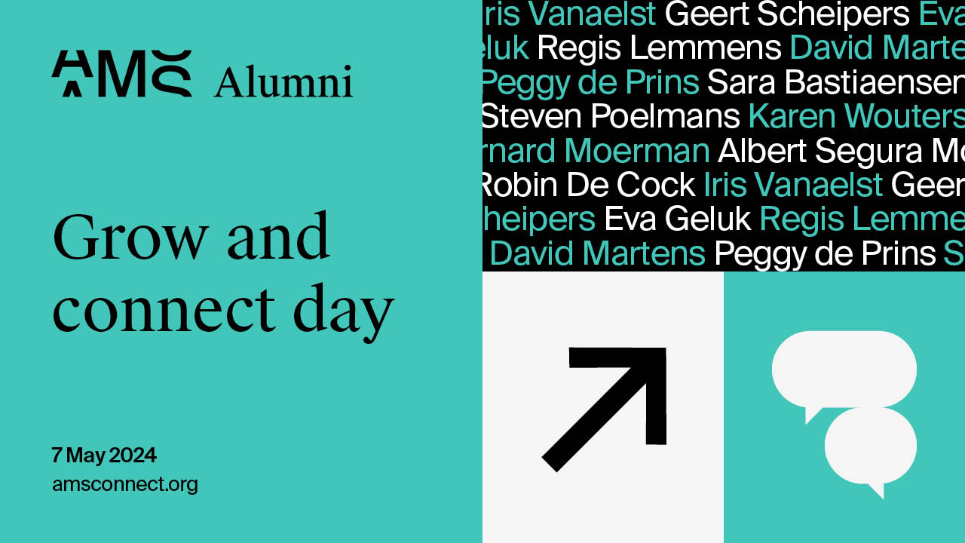

Registration form pay via invoice
Pricing (excl. vat)
Early Bird (until 22 March 2024)
- AMS Alumni: 275 EUR
- Bring a friend: AMS Alumni can register with a partner for 550 EUR total, bringing a friend at our exclusive alumni price!
- Non-alumni: 525 EUR
Normal Fee (from 23 March 2024)
- AMS/ UA Alumni: 375 EUR
- Bring a friend: AMS/ UA Alumni can register with a partner for 750 EUR total, bringing a friend at our exclusive alumni price!
- Non - Alumni: 850 EUR
please fill in the form below and return it to emmanuelle.duval@ams.ac.be
Each participant will receive an email confirming their registration via eventbrite

Company details
Company Name:
VAT Number:
Address:
email of the contact person for invoicing:
Participant 1:
please indicate the fee you are applying for
- AMS Alumni
- Bring a friend
- Non-alumni
First name:
Last name
Email
Job title:
company name:
- Will you join the networking reception in the evening after the afternoon session?
- if you have any dietary restrictions, please indicate them here:
if you have any dietary restrictions, please indicate them here
morning session selection: (pick 1)
- Enabling entrepreneurship: from science to start-up by Robin De Cock, Associate professor of entrepreneurship at Antwerp Management School & Iris Vanaelst, Venturing & Licensing Manager, University of Antwerp
- Strategists vs Heart Surgeons - Parallels and Differences in Complex Decision Making- Geert Scheipers & Dr. Dr. Luc Haenen, AZ Imelda
- From the what to the how - wellbeing and psychological safety in organizations by Eva Geluk, Senior Researcher and Project Leader at Antwerp Management School & Griet Perear
- Leading the Way in ESG and Sustainable Impact Measurement, Jan Beyne, Assistant Professor Sustainability Management
afternoon sessions (pick 1)
- Future of sales: strategies for today and tomorrow - Regis Lemmens, Sales and Marketing Professor, AMS
- Opportunities & risk of using AI in business by David Martens, Professor of Data Science for Business at University of Antwerp
- The dark side of HR by Sara Bastiaensen, PhD and Peggy de Prins, Peggy De Prins Associate Professor of HR, Antwerp Management School
- Leadership unveiled: embracing the diversity of leadership approaches by Karen Wouters, AMS & Steven Poelmans, AMS

Participant 2:
please indicate the fee you are applying for
- AMS Alumni
- Bring a friend
- Non-alumni
First name:
Last name
Email
Job title:
company name:
- Will you join the networking reception in the evening after the afternoon session?
- if you have any dietary restrictions, please indicate them here:
morning session selection: (pick 1)
- Enabling entrepreneurship: from science to start-up by Robin De Cock, Associate professor of entrepreneurship at Antwerp Management School & Iris Vanaelst, Venturing & Licensing Manager, University of Antwerp
- Strategists vs Heart Surgeons - Parallels and Differences in Complex Decision Making- Geert Scheipers & Dr. Dr. Luc Haenen, AZ Imelda
- From the what to the how - wellbeing and psychological safety in organizations by Eva Geluk, Senior Researcher and Project Leader at Antwerp Management School & Griet Perear
- Leading the Way in ESG and Sustainable Impact Measurement, Jan Beyne, Assistant Professor Sustainability Management
afternoon sessions (pick 1)
- Future of sales: strategies for today and tomorrow - Regis Lemmens, Sales and Marketing Professor, AMS
- Opportunities & risk of using AI in business by David Martens, Professor of Data Science for Business at University of Antwerp
- The dark side of HR by Sara Bastiaensen, PhD and Peggy de Prins, Peggy De Prins Associate Professor of HR, Antwerp Management School
- Leadership unveiled: embracing the diversity of leadership approaches by Karen Wouters, AMS & Steven Poelmans, AMS

